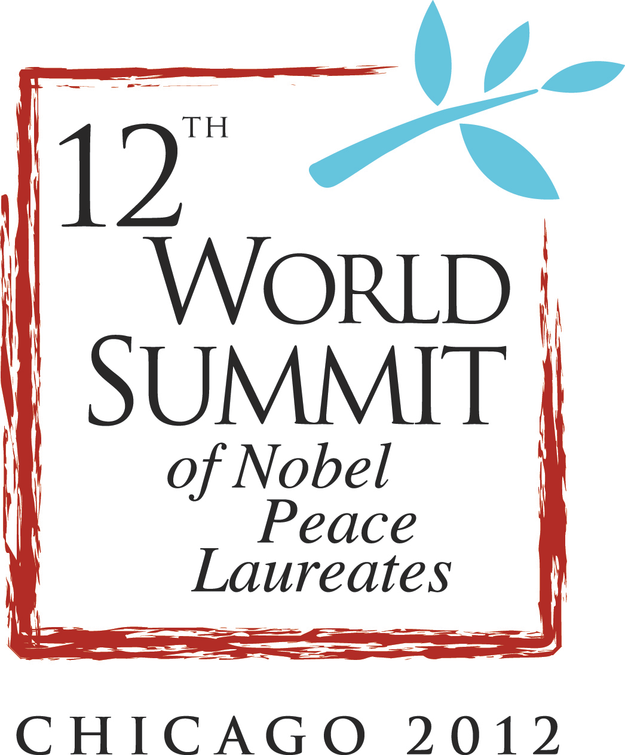
CONTACT
Ashley Dennison
Office: (312) 573-5459
Cell: (303) 552-7460
ashley_dennison@jtpr.com

World Summit of Nobel Peace Laureates to Convene in Chicago
Chicago selected as first North American city to host Nobel Laureates, global dignitaries
for annual summit on human rights, peace and individual activism

FOR IMMEDIATE RELEASE
November 17, 2011

CHICAGO—Mayor Rahm Emanuel today announced that Chicago will host the 12th World Summit of Nobel Peace Laureates—the first such World Summit to be held in North America—April 23-25 at the University of Illinois at Chicago.

The World Summit is internationally recognized as among the most important annual events in the field of peacemaking, attracting hundreds of high-profile leaders and organizations from around the globe. The event is co-chaired by former Soviet President Mikhail Gorbachev and Hon. Walter Veltroni, the former Mayor of Rome. Mayor Emanuel will serve as the Summit’s honorary co-chair.

Mayor Emanuel made the announcement at a news conference at the Jane Addams Hull-House Museum alongside 2012 World Summit Host Committee members: Chris Kennedy, chair of the Board of Trustees, University of Illinois and immediate past president of Merchandise Mart Properties, Inc.; Kerry Kennedy, president of the Robert F. Kennedy Center for Justice and Human Rights; Terry Mazany, president and CEO of The Chicago Community Trust; and Michael Sacks, CEO of Grosvenor Capital Management and vice chairman of World Business Chicago.

“Chicago is honored to be the first North American city to host the World Summit of Nobel Peace Laureates, and we look forward to welcoming distinguished guests from around the globe in April,” said Mayor Emanuel. “The decision to host this event in Chicago reflects the profile of our city as an international leader in civic dialogue and community involvement. While the summit is a global event, it will have a local impact and leave a lasting legacy on our city.”

The three-day summit, themed “Speak Up, Speak Out for Freedom and Rights,” will place a special emphasis on engaging and empowering youth to action through a series of plenary sessions and breakout discussions. Summit organizers are also partnering with the Chicago Public Schools and the Robert F. Kennedy Center for Justice and Human Rights to connect Nobel Laureates in sharing their powerful stories directly with Chicago students in the classroom.

“Human rights defenders, exemplified by Nobel Peace Prize winners, are the basis of our ‘Speak Truth to Power’ program, a global initiative that educates students about courageous people who have demonstrated that each individual has the capacity to create change,” Kerry Kennedy said. “Through their stories, students learn to self-identify as human rights defenders who, when faced with injustice and inequality, speak up and speak out.”

The “Speak Truth to Power” human rights curriculum includes teacher-developed lessons and is currently taught in Chicago high schools. Each student is given a toolkit to help them express themselves and take action regarding issues such as domestic violence and human trafficking, empowering them to enact change in their classroom, community, country and world.

One key panel discussion that will take place during the 2012 World Summit is “Investing in Peace,” a key theme of the Robert F. Kennedy Compass Program. The RFK Compass Program helps global fiduciaries exercise their influence on important issues like human rights, the environment and good governance. As globalization spreads, socially responsible corporate behavior is increasingly relevant to discussions of peace and stability, added Kennedy.

National and regional executives of endowments, foundations, public pension, union and corporate funds will convene for a separate RFK Compass Program conference that will coincide with the 2012 World Summit of Nobel Peace Laureates.

Chicago was selected as the first North American city to host the World Summit due to its rich heritage and international profile. Numerous Nobel Peace Prize winners have hailed from Chicago, among them U.S. President Barack Obama. In 1931, Illinois native Jane Addams became the first American woman to be awarded the Nobel Peace Prize for her international peace efforts and work on behalf of Chicago’s marginalized immigrant communities.

Today, the City of Chicago is both a recognized center of community and civic engagement, and an active player in international affairs. In May 2012, shortly after the conclusion of the 2012 World Summit, Chicago will host the international G-8 and NATO Summits.

"This is a tremendous opportunity to showcase Chicago," said Sacks. "We look forward to hosting this important delegation and showing them what we all know – Chicago is a world-class global city."

The first World Summit of Nobel Peace Laureates was held in 1999 at the suggestion of the Gorbachev Foundation, and the summit has grown over the years, gaining in credibility and importance as it promotes international initiatives and campaigns to foster peace. Each summit’s location is chosen for its unique relationship to the theme of that year. Previous summits include the 2010 Summit on global nuclear disarmament, held in Hiroshima, and the 2009 Summit celebrating the end of the Cold War and reunification of East and West, held in Berlin.
“The MacArthur Foundation knows that individuals with vision, motivation, and creativity can change the world – as the Nobel Peace Prize winners have done,” said Robert Gallucci, president of the John D. and Catherine T. MacArthur Foundation, and member of the 2012 World Summit host committee. “We look forward to hosting the Nobel Laureates in Chicago, hearing their ideas for the future, and joining with them in a hopeful conversation.”

Previous World Summits have attracted a diverse and impressive range of participants and honorees, including Nobel Peace Laureates such as Mikhail Gorbachev, the Dalai Lama, F.W. de Klerk and Lech Walesa; leaders of Nobel Peace Prize-winning organizations such as Jayantha Dhanapala, President of Pugwash Conferences on Science and World Affairs and Jody Williams, founding coordinator of the International Campaign to Ban Landmines; and personalities in media and entertainment such as Tom Brokaw, George Clooney, Don Cheadle, Bono and Annie Lennox.

“For more than a decade, the World Summits have addressed topics of fundamental importance for building a world of peace,” said former South African President and Nobel Peace Laureate Frederik Willem de Klerk by video message. “I look forward to joining my fellow Nobel Laureates and the citizens of Chicago in a rich and meaningful dialogue about human rights and youth activism at the World Summit this spring.”

Additionally, one local nonprofit with a focus on community organizing will receive an award at the 2012 World Summit for their dedication and devotion to making a difference in improving the human condition. Other awards will also be presented to chosen high-profile activists from around the globe.

The Permanent Secretariat of the World Summit of Nobel Peace Laureates, a non-profit organization based in Rome, coordinates the activities of Nobel Laureates and organizes the World Summit annually. To plan and organize the 2012 World Summit in Chicago, the Permanent Secretariat is collaborating with The Chicago Community Trust, a non-profit community foundation that seeks to continue Chicago’s tradition of philanthropy and improve the quality of life for all local residents.

The Chicago Community Trust is also a sponsor of the 2012 World Summit, along with fellow sponsors the John D. and Catherine T. MacArthur Foundation, BMO Harris Bank, Wendy and Jim Abrams, and in-kind donors Chrysler and JW Marriott.

“The Chicago Community Trust is proud to support the city and to collaborate with the Permanent Secretariat to organize the 2012 World Summit of Nobel Peace Laureates in Chicago,” said Mazany. “This Summit will bring together global dignitaries, civic leaders, national organizations, local citizens and students for a substantive event focused on human rights and peace.”

Today’s press conference also featured video messages from Nobel Peace Laureates Frederik Willem de Klerk, former President of South Africa, and Archbishop Desmond Tutu. Video messages are available for download at https://jtdigital.box.net/s/ryu1k2xj8o8zaky1kbtl

For more information on the Permanent Secretariat and the World Summit of Nobel Peace Laureates, please www.nobelforpeace-summits.org, and to register for more information on the upcoming Chicago summit, visit www.nobelsummitchicago.org.

###

